Model Standard Operating Procedure
on
Right to Information
for
Local Government Department,
Khyber Pakhtunkhwa

Contents
Acronyms 1
Introduction 2
Overview of Khyber Pakhtunkhwa Local Government Department 2
Standard Operating Procedure on Right to Information (RTI) 3
1. Nomination of Public Information Officer (PIO) 4
2. Training of PIO 5
3. Proactive Disclosure of Information 6
4. Responding to Requests 10
5. Reporting 14
6. Records Management 15
7. Public Outreach 16

Acronyms
ADLG Assistant Director Local Government
FAQ Frequently Asked Questions
KP Khyber Pakhtunkhwa
KPIC Khyber Pakhtunkhwa Information Commission
LGE&RDD Local Government Election and Rural Development Department
LG Local Government
LoGo Support to Local Governance Programme
PIO Public Information Officer
RMS Request Management System
RTI Right to Information
SCD State Citizens Dialogue
SOP Standard Operating Procedure
TMA Tehsil Municipal Administration
VC/NC Village Council/Neighbourhood Council

Introduction
This Model Standard Operating Procedure (SOP) on the Right to Information (RTI) has been prepared by the GIZ-LoGo project as part of its work on State-Citizen Dialogue. This work area has identified the Local Government Election and Rural Development Department (LGE&RDD or LG Department) as a provincial level public body to support regarding the implementation of the Khyber Pakhtunkhwa Right to Information Act 2013 (KP RTI Act). The overall goal of this SOP is to help the Local Government Department prepare its own SOP on this issue, which may then provide an inspiration and guidance to other provincial-level public bodies. The underlying objectives of this SOP are:

- To provide a brief overview of what has been done so far by the Local Government Department to implement the KP RTI Act 2013 in different areas
- To outline better implementation practice in different areas
- To set out (draft) internal rules for the LG Department as relevant in different areas
- To set out (draft) two-year commitments for the LG Department in different areas

The SOP starts by providing a brief overview of the situation in KP Local Government Department, as well as of the main operations of the Department at the district level. It then covers seven different action areas relating to RTI, as follows:
- Nomination of Public Information Officer (PIO)
- Training of PIO
- Proactive Disclosure of Information
- Responding to Requests
- Reporting
- Records Management
- Public Outreach

The SOP covers a period of two years. It provides the framework of rules that will govern the Local Government Department’s work during this period, as well as the commitments it is making to implement the RTI Act over this time period. It is designed to be implemented by the provincial LG department and not for its counterparts at other levels of government, although they may wish to use it as a basis for developing their own SOPs on RTI.

Overview of Khyber Pakhtunkhwa Local Government Department
The Local Government, Elections and Rural Development Department (LGE&RDD) is working to respond to the specific needs of the citizens of Khyber Pakhtunkhwa falling within the ambit of local governance. The Department has been assigned the responsibility to implement the Khyber Pakhtunkhwa Local Government Act 2013 to achieve the stated objectives of the local government reforms introduced by the Government of Khyber Pakhtunkhwa. The Department also has regulatory and administrative functions to ensure that the local governments throughout the province perform their roles and functions within the policy framework introduced under the new local government law.

The Vision of the KP Local Government, Elections and Rural Development Department is: “To enhance the local governments’ ability to generate revenue and optimally utilize development funds while meeting the needs of their respective administrative units, including the ability to deliver municipal services and provide infrastructure”.

In terms of organisational structure, most of the positions in the LG Department are filled including, in addition to a relatively streamlined management structure:

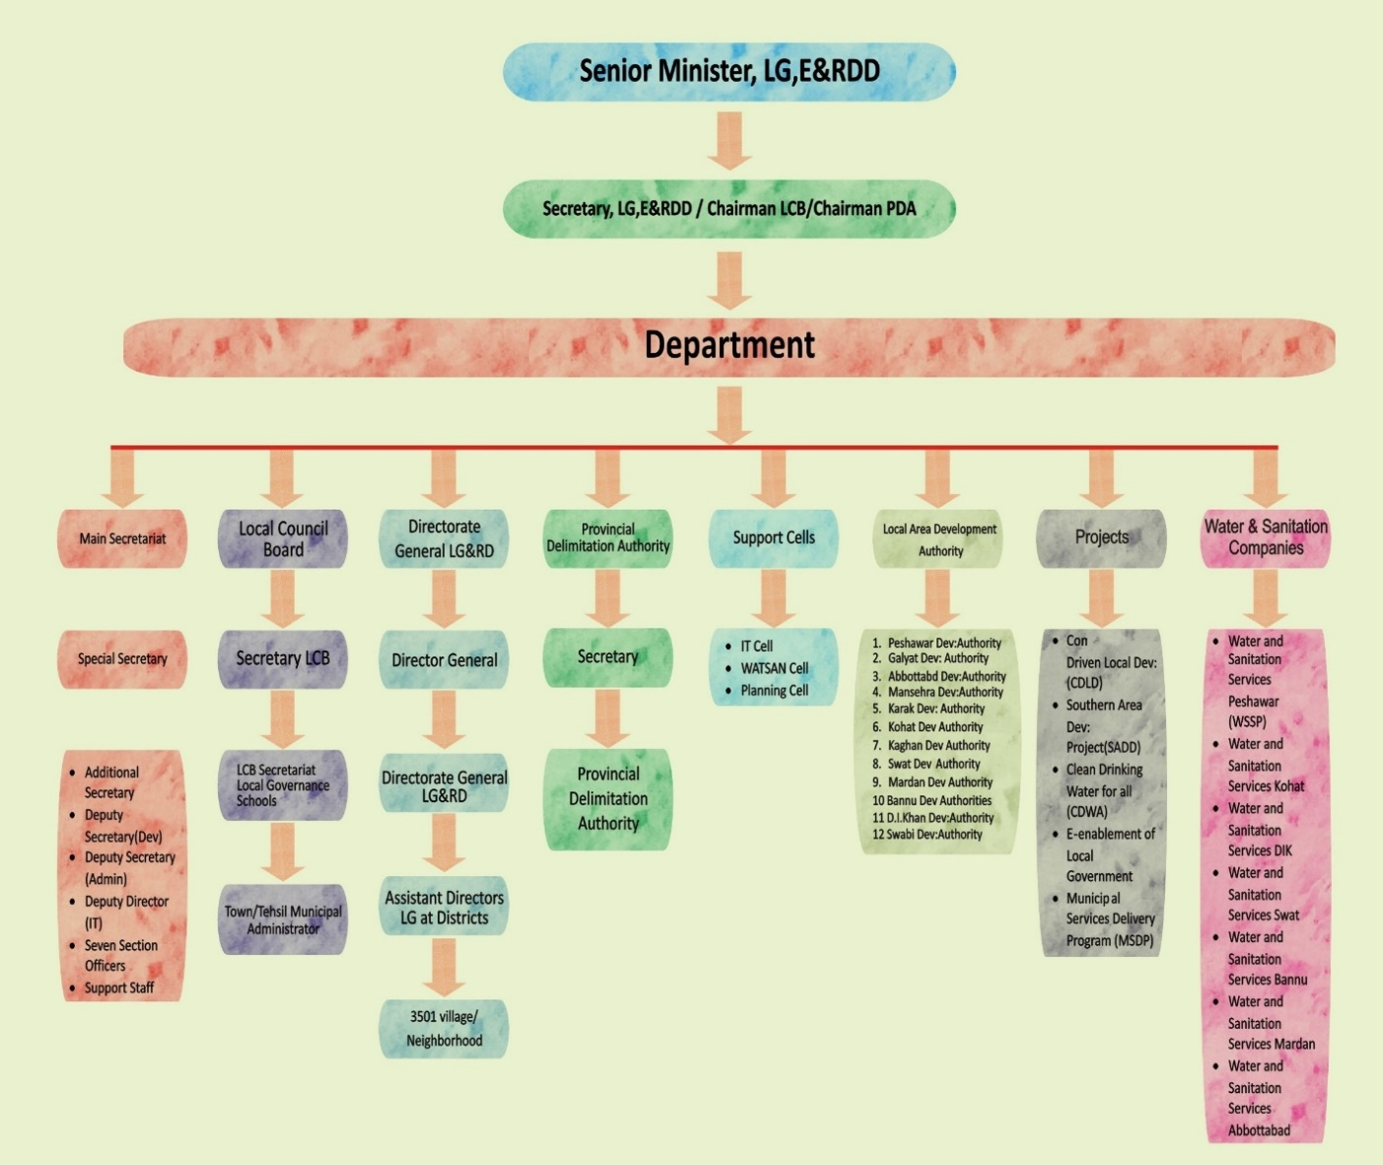

Strategic interventions of the KP Local Government Department:
- Improving citizen participation and bringing the state closer to the citizen
- Outlining a framework for shared commitments of the government and development partners
- Developing a common understanding of the local government system
- Setting the context for delivery of assistance of development partners for strengthening local government system
- Overseeing the placement of systemic arrangements, resource allocation and support institutions
- Contributing through exchange of experience and lessons learnt

Standard Operating Procedure on Right to Information (RTI)
The Government of Khyber Pakhtunkhwa has taken important initiatives to enhance transparency, service delivery and citizen integration in governance. A key part of this was the adoption of the Khyber Pakhtunkhwa Right to Information Act 2013, which is a very important milestone. Based on this Act, all of the public bodies in Khyber Pakhtunkhwa are supposed to disclose information to citizens. Implementation of the Act is, however, complex and, so far, most of the required measures have been taken. These SOPs covers six different action areas relating to RTI, as follows:

Nomination of Public Information Officer (PIO)
A key institutional measure to implement the RTI Act is the appointment of a PIO, an official with dedicated responsibilities for ensuring that the public body meets its obligations under the law. A key role of PIOs is to ensure that citizens can easily lodge RTI applications to get information and that those applications are processed in accordance with the rules in the Act. Because of its size and complexity, the Local Government Department has a very large number of PIOs working for it at the provincial (department), district, tehsil and local levels.

Current Situation
There are around 3000 PIOs in public bodies of Khyber Pakhtunkhwa. Out of which 2496 PIOs are nominated by the Local Government Department in KP, which is a huge number as compared to other public bodies in the province. These PIOs are appointed at all four tiers of the local government structure i.e. provincial, district, tehsil and Village/Neighbourhood Councils (VC/NC) level. The PIO has been given a formal (written) mandate, along with a Job Description or set of ToRs to define his/her roles.

Department-wise Total No. of PIOs in KP-Local Government Department
S.# | Department/Section | No. of PIOs
 | Local Government Secretariat | 1
 | Local Government Directorate | 1
 | Local Council Board (LCB) | 1
 | Water & Sanitation Services Companies (WSSCs) | 6
 | Provincial Development Authorities | 12
 | Assistant Director Local Govt. @ District Level | 17
 | Tehsil Municipal Officer (TMO) @ Tehsil Level | 45
 | Secretary Village/Neighborhood Councils level | 2413
 | Total | 2496

District-wise Total No. of PIOs in KP-Local Government Department
S.# | District | No. of PIOs in AD-LG Office | No of PIOs in TMA offices | No. of PIOs @ VC/NC
1 | Abbottabad | 1 | 2 | 209
2 | Haripur | 1 | 2 | 180
3 | Mansehra | 1 | 3 | 194
4 | Battagram | 1 | 2 | 90
5 | Torghar | 1 | 2 | 40
6 | Peshawar | 1 | 4 | 346
7 | Charsadda | 1 | 3 | 146
8 | Nowshera | 1 | 3 | 153
9 | Mardan | 1 | 3 | 231
10 | Swabi | 1 | 4 | 160
11 | Kohat | 1 | 2 | 91
12 | Hangu | 1 | 2 | 62
13 | Karak | 1 | 3 | 61
14 | Bannu | 1 | 2 | 110
15 | Lakki Marwat | 1 | 2 | 96
16 | D.I. Khan | 1 | 5 | 174
17 | Tank | 1 | 1 | 70
 | Total | 17 | 45 | 2413
Grand Total |  | 2475

Better Practice
Keeping in view the increase in citizen’s request for information, the department has recently issued a notification for the appointment of PIOs in all the three tiers of local government in the province. PIO will often need help from other staff to implement the RTI Act. This may be required during the processing of requests (for example to find the information that is being requested or to assess it for exceptions – see below), for proactive disclosure of information or for other issues. Training is part of the answer to this, but it is also important to impose an obligation on all staff to cooperate with the PIO in the exercise of his or her functions. This is also useful to incorporate it into the internal rules of each public body because many staff may not be aware of the Act.

Rules of Business
The following are suggested Rules of Business relating to this issue:

All four levels of government within the LG Department, namely the provincial, district, tehsil and council levels, are required to appoint PIOs to deal with requests for information.

All officers and contract staff employed by the LG Department are required to cooperate with the PIO in the discharge of his or her functions. This shall normally include responding to requests for assistance from the PIO promptly (normally initially within two working days and more quickly for follow-up requests) and ensuring that appropriate efforts are made to provide him or her with the needed assistance.

Commitments
The LG Department makes the following commitments in relation to this issue:
- A set of rules, including the rules on appointing and assisting PIOs along the lines of the above, will be adopted within six months.
- Where this is not already the case, PIOs will be appointed at all levels within six months.

Training of PIO
Current Situation
The PIO and other staff have a very reasonable knowledge about RTI generally, the RTI Act, the proactive disclosure of information and the Request Management System (RMS). However, the rest of the PIOs (in District, Tehsil and VC/NC level) have very limited knowledge of the RTI Act. The LG department has recently distributed the Job Description (JDs) for PIOs to all of the PIOs of the LG department. The JDs briefly describe the role and responsibilities of PIOs in English and Urdu language.

One-hour training module on RTI is already included in the Training Manual of Elected Local Government representatives (i.e Nazims/Naib Nazims) and Secretaries VC/NC by Local Governance School (LGS) Khyber Pakhtunkhwa.

Better Practice
It is essential that PIOs receive appropriate training on RTI. Without this, they cannot possibly be expected to implement the RTI Act properly and, in particular, to respond to requests in a positive manner (i.e. in accordance with the Act, including the exceptions) within the required time limits. At least two days of basic training are required for more central PIOs to be able to undertake basic RTI functions, while local (Council) level PIOs should receive at least two hours of training to start with.

Over time, all staff should be provided with at least some training on RTI, which can, among other things, be provided by the PIO once he or she is trained. A two-hour module on RTI should be sufficient for regular staff and VC/NC PIOs. Such modules can be provided as stand-alone sessions (for example, over an extended lunch break or afternoon session) or incorporated into other training programmes (such as the pre-service training that most civil servants receive or any ongoing training programmes that may be offered).

Rules of Business
There is no need for Rules of Business on this issue.

Commitments
The Local Government Department makes the following commitments in relation to this issue:
- PIOs operating at the provincial, district and tehsil levels (approximately 70 individuals) will be provided with a two-day training programme on RTI within six months. In case the PIO is replaced, the new person will be provided with a two-day training programme on RTI within three months of being appointed.
- All PIOs operating at the Council level will be provided with at least a two-hour training programme on RTI. At least 75% will have received such training by the end of six months and 95% will have received it by the end of one year.
- By the end of a two-year period, at least 50% of the staff at the Local Government Department, including the Clerks and Assistants, will receive at least some basic training on RTI.

Proactive Disclosure of Information
The proactive disclosure of information – that is to say the dissemination of key information to the public even in the absence of any request for that information – is a key means of implementing RTI. It is the most efficient way of disclosing information, because it is much easier to make information available proactively than to process even one request for the information, and it results in everyone being able to access the information, not just the requester.

Current Situation
The Local Government Department has huge potential for proactive disclosure, including through its very extensive outreach via the offices at VC/NC level to provide services to the citizens. The Local Government Department has its own website where information is proactively disclosed electronically. In addition to its official website, the LG Department has its social media presence and other mechanisms for proactive disclosure of information under the RTI Act. Permanent IT and Communication professionals are working in the department for these tasks.

Through its website, the LG Department provides information about functions, services, budgets and staff at one place and give a clear picture of services provided to the citizens and answers to common questions.

According to the RTI Act, all public bodies must disclose the following types of information on a proactive basis:
- Vision & Mission
- Their Functions
- Organogram of the Organisation
- Details of key staff
- Services
- Budgets
- Statistics/facts & figures
- Tenders
- Future Plan
- RTI Act & Rules
- Information about PIO
- Gallery
- Forms
- Contact Us
- FAQs

Better Practice
The website is by far the easiest and most efficient way to disclose information on a proactive basis. It provides a central location for all information relating to the public body and information on the website is accessible to anyone who has access to the Internet. Furthermore, once the website is up and running, it is very easy to disclose information in this way.

At the same time, focusing only on a website is not enough in terms of proactive disclosure. First, many people in the Districts do not have access to the Internet at all and, from among those that do, many only have access via a mobile phone, which provides only limited accessibility (and, even then, access can be quite limited where website pages have not been specifically designed for mobile access). Furthermore, even where citizens do have access to the Internet, they will not necessarily look there for information about the Local Government. As a service provider, it is crucially important for the Local Government Department to ensure that LG messages get widely disseminated among the public, and for this it needs to use a variety of tools to reach out to the public.

One of the most effective means of disseminating information digitally outside of the website is via social media, including Facebook and WhatsApp, both of which are popular in Pakistan. This is a low-cost and effective way for the Local Government Department to reach out to citizens.

The Local Government Department should also explore non-digital means of reaching out to citizens. In this respect, it has huge potential through its extensive outreach to citizens. This includes its network of 3501 Village/Neighbourhood Councils – including the AD-LG and TMA Offices – as well as through its very extensive outreach via the Nazim and Councillors. Publication can take place via bulletin boards in the VC/NC Offices, and very important content can be distributed in both printed and oral form via Secretaries of VC/NCs.

Rules of Business
The following are suggested Rules of Business relating to this issue:

Staff responsible for producing documents falling within the scope of the proactive publication requirements in the RTI Act shall, whenever those documents are available in electronic versions, and within two weeks of those documents being finalised, provide copies to the IT team, along with basic metadata (information about the nature of the document, such as type of document, date, unit responsible for producing it, etc.), to allow for its publication on the website.
The IT team/Web Master of KP Local Government website should be kept in CC of all-important notifications/ documents etc. which are of public importance for publicising/uploading it on KPLG website

Commitments
The Local Government Department makes the following commitments in relation to this issue:
- The PIO will, within six months, prepare an annotated list of information subject to proactive publication, based on the list above, which comes from the RTI Act (see below). The aim will be to make it clear to Local Government Department staff which documents need to be provided to the IT team for uploading on the website. To do this, the PIO will consult with the IT Team as well as staff working in different sections of the department.
- Within six months, the Local Government Department will revisit its presence on key social media platforms and start using these tools to disseminate information and messages.
- Within one year, the LG Department will provide at least 90% of the information subject to proactive publication on its website.
- Within one year, at least 50% of the local government facilities operated by the Nazim will provide information via bulletin boards and this figure will increase to 80% within two years.
- Wtihin two years, 80% of Secretaries VC/NC will be providing information regularly to rural populations.

Proactive Disclosure of Information @ KP Local Government Department
Proactive Disclosure of Information relating to the KP Local Government Department (LGE&RDD) as required under Section 5 of the KP RTI Act, 2013
The following categories of information shall be duly published by KP Local Government Department in an up-to-date fashion and in a manner, which best ensures that they are accessible to those for whom they may be relevant, including over the Internet, subject to reasonable restrictions based on limited resources:
S.# | Section 5 of the KP RTI ACT, 2013 | Relevance to the KP Local Government Department
5(a) | Acts and subordinate legislation such as rules, regulations, notifications, bye-laws, manuals and orders having the force of law in the Province, including being made available at a reasonable price at an adequate number of outlets to ensure reasonable access by the public; | KP Local Govt Act 2013  Rules & regulations  Notifications  Manuals  Office orders
5(b) | Information about the public body, including its organization, functions, duties, powers and any services it provides to the public; | About LGE&RDD  Functions of the LE&RDD  Powers of the LGE&RDD  District Government offices of the LGE&RDD  TMA Offices  VC/NC Offices  Local Governance School
5(c) | A directory of its officers and employees, including a description of their powers and functions and their respective remunerations, perks and privileges | LGE&RDD organogram  Directory/seniority list of the LE&RDD employees  Distribution of work  Remuneration (other perks & privileges admissible to civil servants i.e. medical, house subsidy etc.)
5(d) | Norms and criteria set by the public body for the discharge of its functions, including any rules, manuals or policies used by its employees to this end; | Service rules  Summaries of the LGE&RDD currently being vetted/finalized by the law dept.
5(e) | A description of its decision-making processes and any opportunities for the public to provide input into or be consulted about decisions; | Description of decision-making processes of the department
5(f) | Relevant facts and background information relating to important policies and decisions which are being formulated or have been made and which affect the public; | Complaints of citizens  Local government policies  Show cause notices
5(g) | A detailed budget of the public body, including proposed and actual expenditures; | Budget details, including proposed and actual expenditures
5(h) | Details about any subsidy or benefit programmes operated by the public body, including details about the amount or benefits provided and the beneficiaries; | Special programs of the department (like BRT) and other mega projects
5(i) | Particulars of the recipients of concessions, permits, licenses or authorizations granted by the public body; | List of Registered Housing Authorities  List of registered contractors
5(j) | The categories of information held by the public body; | Details about the total numbers of VC/NCs in the province  Details about information requests
5(k) | A description of the manner in which requests for information may be made to the public body, including the name, title and contact details of all [Public Information Officers;] and | RTI PIO Details (@ LGE&RDD department level, District, Tehsil and VC/NC level); forms; guides for requesters; RTI request/complaint process flowchart
5(l) | Such other information as may be prescribed. | 1. RTI request process flowchart  2. RTI complaint process flowchart  3. Contacts

Additionally, the provincial government of Khyber Pakhtunkhwa recently issued guidelines for proactive disclosure of information under Section 5 of KP RTI Act, 2013. These guidelines mainly address the code of conduct for proactive disclosure of official information on social media including Facebook and twitter accounts of the public bodies. In this regard, the Performance Management and Reforms Unit (PMRU) in the office of chief secretary, Khyber Pakhtunkhwa give orientation sessions to concerned IT staff of the public bodies.

Responding to Requests
Any Pakistani citizen or legal entity can submit a request for information or RTI application. They need to provide their contact details, the name of the concerned public body and describe the information they are seeking.

Responding to requests for information from citizens is at the heart of the RTI Act and an important part of the law is devoted to this issue. It sets out clear rules governing the receipt and processing of requests which all public bodies are required to follow. A key challenge here is to respond to requests in accordance with the Act and within the time limits it sets out (namely as soon as possible and in any case normally within 10 working days). A second major challenge here is deciding which information may be refused to be provided because it falls within the scope of the regime of exceptions.

Current Situation
The current procedure for making a request for information from the Local Government Department is through a paper application addressed to the concerned PIO. So far, the Local Government Department has received more than 461 requests for information.

Better Practice
According to the RTI Act, citizens may make requests for information either on the form or in any other way (as long as they provide the necessary information, which is just a description of the information and an address for providing the information and does not include the reason they want the information) (sections 10(1) and (3)). The form shall be made available in printed and electronic formats (section 10(2)). The PIO shall assist requesters who cannot produce a written application (for example due to illiteracy or disability) or who are facing difficulty describing clearly the information they want (section 10(4)). If an application is provided to an officer who is not the PIO, that officer should send the request to the PIO (section 11(1)).

After receiving an RTI application, the PIO should provide an acknowledgment of its receipt to the requester (section 10(1)). No fee may be charged for the form or for processing the application (section 10(6)). Better practice at this point is to record the application in a central registry. This both allows for tracking of applications and provides an overview of all of the applications received. A good register can help a lot with reporting (see section below on Reporting). To this end, better practice here is to keep reasonably detailed information about the application in the register (such as information about any fees charged, whether the application was transferred, what exceptions were relied upon if the request was refused, in whole or in part, and so on).

Once an application is received, the first step is to determine whether the public body holds the information. In some cases, the PIO will know this already, but in other cases he or she may need to ask other officials about this. It the public body does not hold the information, it should, if it is aware of another public body which does hold the information, transfer the application to that public body and inform the requester about this. If it does not know about such other public body, it may return the application to the requester (section 11).

If the public body does hold the information, the second step is to determine whether or not it is exempt (i.e. whether or not all or part of the information falls within the scope of the exceptions set out in section 13 of the Act). Some system needs to be agreed for this. Ideally, where this is clear (i.e. because the information is either obviously exempt or not exempt), the PIO should simply make the decision. Where this is not clear, the PIO should consult with the official who is responsible for the information to come to a decision on this. In more complex or sensitive cases, there may be a need to refer the matter to a higher officer. At this stage, the PIO may also want to assess whether or not the information has already been disclosed proactively.

The next (third) step is to provide the information, provide part of the information and refuse part of it, or refuse all of it (or to inform the requester that the information is already available and where to find it, such as the URL or physical location). Where all or part of the information is being refused, the requester should be informed about this, about the exact clause of section 13 which is being relied upon (for example, section 13(1)(a), national security), and his or her right to appeal against that decision (section 10(8)).

Where all or part of the information is being provided, the requester shoud be informed about that, and about any fee that he or she has to pay (which may only be for the cost of reproducing and sending the information, in accordance with the schedule of fees established by the Khyber Pakhtunkhwa Information Commission) (section 10(6)). Better practice is to provide at least 10-15 pages for free (because the cost and effort to collect the tiny fee for such a small number of pages is not worth it). The public body also needs to provide the information in the format stipulated by the requester (if he or she has indicated a format, such as a physical or electronic copy or opportunity to inspect the documents) (section 10(5)). It may be noted that the format will affect the fee (for example, electronic copies are free because they do not involve reproduction or sending costs). Where the information is provided in a physical copy, the PIO should attach and sign a certificate indicating that it is a ‘true copy’.

As noted above, all of this should be done as soon as possible and normally within a maximum of 14 working days, which may be extended by another 14 working days “where this is necessary, including because the request requires a search through a large number of records or consultation with a third party or any other public body” (section 10(7)). Where the information relates to the “life or liberty of a person”, it should be provided in two working days (section 10(7)). Figure 1 below shows this process in a flowchart format.

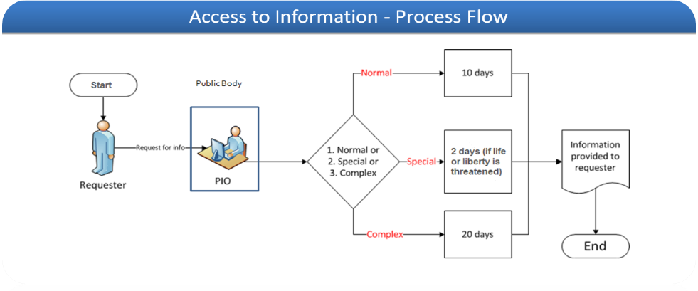
Figure 1. RTI application procedure. (Source: KPIC website)

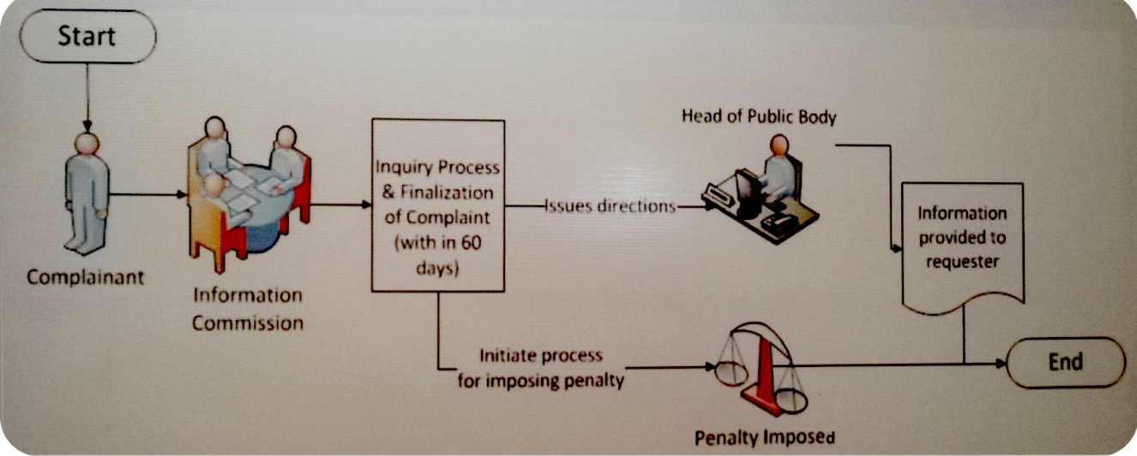
Figure 2. RTI complaint procedure. (Source: KPIC website)

Rules of Business
The following are suggested Rules of Business relating to this issue:

Whenever any officer of the Local Government Department receives an RTI application which he or she cannot deal with him- or herself within two working days, he or she shall forward that application to the PIO within two working days.

Whenever any officer of the Local Government Department receives a request from the PIO as to whether or not he or she is aware of information held by the Local Government Department that is responsive to an RTI application, he or she shall respond, honestly and fully, to that request within two working days, provided that if he or she needs more time to locate all of the responsive information, this period may be extended to four working days.

The PIO shall have the authority, where he or she decides that information that has been requested is clearly either not exempt or exempt, to provide or to refuse to provide that information in response to an RTI application.

Where the PIO cannot decide on his or her own whether information that has been requested is clearly either not exempt or exempt, he or she may consult with the officials who are responsible for the information to decide this matter and, together, they shall have the authority to provide or to refuse to provide that information in response to an RTI application.

Where the PIO and the officials who are responsible for information that has been requested either cannot decide or cannot agree as to whether the information is either not exempt or exempt, the PIO may consult with his superior officer who shall have the authority to provide or to refuse to provide that information in response to an RTI application or to refer the matter to a more senior officer.

Any officer who the PIO consults in relation to the question of whether or not information that has been requested is either not exempt or exempt shall render all reasonable assistance to the PIO in the matter.

No officer shall be subject to any employment related or other official detriment for any decision made in good faith as to whether, in response to an RTI application, information is exempt or not exempt.

Commitments
The Local Government Department makes the following commitments in relation to this issue:
- The Local Government Department will, within four months, develop and provide access to a simple form for making RTI applications at its LG Secretariat and Directorate at provincial capital. Over time, an effort will also be made to provide access to these forms via Secretaries of VCs/NCs.
- Within one year, the Local Government Department will make the form available on its website and via an email request to the PIO, and will make the necessary arrangements to ensure that the PIO can process applications made on electronic forms (including access to an email to communicate about the request).
- The PIO will provide assistance to all requesters who need it within three working days of becoming aware of that need.
- The PIO will provide a receipt acknowledging an RTI application within three working days 70% of the time and within five working days 95% of the time.
- Within four months, the PIO will put in place a basic system for registering RTI applications. To facilitate this, each application will be allocated a unique reference number. Within one year, the PIO will, working with the IT team, develop a template for all of the information that is to be captured in the registration system and, within 18 months, an electronic registration system that responds to those requirements will be made operational.
- The PIO will provide a written response to RTI applications for information the Local Government Department does not hold within three working days 70% of the time and within five working days 95% of the time. Where the application has been transferred to another public body, the notice to the requester will indicate the public body to which it has been transferred.
- The PIO will provide full notice (i.e. with all of the information that is required) in response to all RTI applications, whether the notice is about a refusal to provide the information, about information that is being provided, or about a partial refusal and partial provision of information.
- The notice indicated above will be provided within 14 working days at least 80% of the time and within 28 working days at least 95% of the time (and, in the latter case, an indication of the extension will be notified to the requester within the original 14 working days).
- The Local Government Department will not charge where the response to an RTI application involves copying of 15 or less pages.
- Where a requester asks for information in electronic format, the Local Government Department will respect that in 80% of the cases.

Reporting
Pursuant to section 9 of the RTI Act, each public body is required to publish an “annual report of its activities under this Act during the previous financial year by 31 August each year”. The report needs to follow any rules adopted by the government in this regard, and to be made available for inspection for free and for purchase at a reasonable cost.

Current Situation
The Local Government Department has not so far provided an annual report on its activities under the RTI Act.

Better Practice
Better practice in this regard is for public bodies to prepare reasonably detailed reports on an annual basis of what they have done to implement the RTI Act. These can be included in their general annual report, if they produce one, or created as a separate document. They should then be uploaded onto the website, ideally in a special section dealing with RTI, and also made available in printed format at the main offices of the public body.

An important part of these annual reports is to provide information about the RTI applications that the public body has received. This should include the following types of information about RTI applications (most of which should be captured on a regular basis via the RTI applications registry):
- the number of RTI applications received, along with statistics on the manner in which they were received (i.e. in person, by mail and so on);
- the number of times assistance was provided to requesters;
- the number of RTI applications which were granted or refused, in full or in part;
- the average time taken to process RTI applications and the number of times an extension was required;
- for RTI applications which were granted, in full or in part, information about the format in which access was provided (i.e. a paper copy, an electronic copy and so on);
- for RTI applications which were granted, in full or in part, information about any fees charged;
- for RTI applications which were refused, in full or in part, information about the grounds for the refusal, including the number of times each exception was relied upon;
- the number of RTI applications for information which was not held by the public body, the number of RTI applications transferred to other public bodies and the number of requesters referred to information which was already published; and
- the number of applications for internal review and complaints to the Commission and outcome of these reviews and complaints.

It should also include the following:
- a general overview of the extent to which the public body has met its RTI targets;
- whether or not the public body has established a website and, if so, a description of the types of information that are disclosed via the website;
- the extent to which the public body has made information available on a proactive basis in other ways than via its website, including the main types of information published and the key ways in which it was disseminated;
- a description of the steps taken to improve records management practices;
- a description of any training provided to officials; and
- a description of challenges and recommendations regarding RTI implementation.

Rules of Business
There is no need for Rules of Business on this issue.

Commitments
The Local Government Department makes the following commitments in relation to this issue:
- Within six months it will publish its first annual report on RTI implementation covering as many of the categories of information above as possible.
- Within 18 months it will have put in place methods to ensure the systematic collection of the categories of information above (i.e. via the electronic RTI application registration system) and their reflection in the annual report.

Records Management
It is clear that a public body cannot provide access to information or records it cannot find. Furthermore, if its records are not managed properly, it will waste time looking for information which is the subject of an RTI application, thereby delaying its responses to applications. According to section 8 of the RTI Act, public bodies are required to maintain their information in an easily accessible manner and to progressively digitise their information.

Current Situation
The Local Government Department is currently using the Khyber Pakhtunkhwa Manual of Secretariat Instruction 2008 for records management practices.

Better Practice
Records management is a complex science. The establishment department of Khyber Pakhtunkhwa is a responsible authority to set minimum standards for record management, provide assistance to public bodies to implement those standards in practice and then monitor the extent to which they did that. It is, however, relatively easy for public bodies to at use the existing/current Manual of Secretariat Instructions and to adopt and apply basic records management standards for their own use.

Rules of Business
There is no need for Rules of Business on this issue.

Commitments
The Local Government Department makes the following commitments in relation to this issue:
- Within one year the PIO will, in consultation with other officials and the IT team, extract a set of at least basic records management standards from the Manual of Secretariat Instruction to apply within the Local Government Department. These shall at least contain rules regarding:
  - The metadata (information about information) required to be kept on records held.
  - Rules on referencing, titling and indexing, so as to facilitate the quick and easy location and retrieval of information.
  - Rules on record-storage systems so as to prevent damage to records, to ensure safety, including by meeting fire regulations, and to protect against unauthorised access, while still maintaining accessibility.
  - Rules on the disposal of files/records once they are no longer being used by the Local Government Department, either through transfer to the archives or through destruction.
  - Specific standards for the handling of electronic records, including metadata, security, organisational systems, appropriate cross-referencing with paper counterparts, and data integrity over time.
- Within two years, with the help of Khyber Pakhtunkhwa Staff Training Institute (STI), key staff at the Local Government Department will be made familiar with the records management standards and have started to implement those standards across the department.

Public Outreach
It is clear that if the general public is not aware of its right to information, it will not use this right and the rate of RTI applications will be low. Experience across many countries shows that where the number of requests is low, implementation in general is weak. Put differently, it is hard to expect public bodies to make a huge effort to implement a law which only a small number of citizens appear to benefit from. According to sections 25(3)(e) of the KP RTI Law, the Khyber Pakhtunkhwa Information Commission may (but not must) undertake mass awareness campaigns and prepare a user handbook for requesters.

Current Situation
So far, as noted above, the Local Government Department has received 461 RTI applications since Dec-2013 when the RTI Law in KP was enacted. Given the important role played by the LGE&RDD and the fact that almost every citizen, over time, takes advantage of local government services, this strongly suggests that the level of awareness among the citizens of the province regarding the RTI Act is high. However, the Local Government Department has also taken direct initiatives to raise public awareness about RTI in the training of local government representatives and general citizens (in CeDP training: Citizens Engagement in Development Planning) through Local Governance School (LGS) and other donors.

Better Practice
It is common for RTI laws to allocate the main responsibility for raising public awareness to a central body, such as the oversight commission, as has been done in Khyber Pakhtunkhwa. At the same time, the capacity of certain public bodies, especially those that provide direct services to citizens, as the Local Government Department does, to reach out to citizens means that they can play a crucial role in supporting any central outreach efforts.

There are many potential ways that public bodies can support central awareness-raising efforts. Where central materials – such as flyers, brochures, banners and/or posters – have been prepared, these can be distributed through the public access points of different public authorities (such as VC/NC offices). In the case of the Local Government Department, there is also the very grassroots outreach system staffed by Secretaries of VCs/NCs and elected representatives. While they would need to be trained to become direct vectors for awareness raising, they could certainly distribute materials and forms for making requests. They could also be given basic prep materials which would be enough to enable them to mention RTI briefly when they were undertaking their other awareness-raising activities.

Rules of Business
There is no need for Rules of Business on this issue.

Commitments
The Local Government Department makes the following commitments in relation to this issue:
- Within six months, the public waiting areas in all Local Government Department Secretariat and Directorate will display posters and other available promotional material on RTI and, within one year, this will be expanded to cover at least 85% of all 153 VCs/NCs at District Nowshera. If no material is available, the Local Government Department will, on its own, prepare at least posters to display at its VC/NC offices.
- Over time, an effort will be made to raise awareness at the very grass-roots levels through Secretaries VC/NC, including through notice boards

