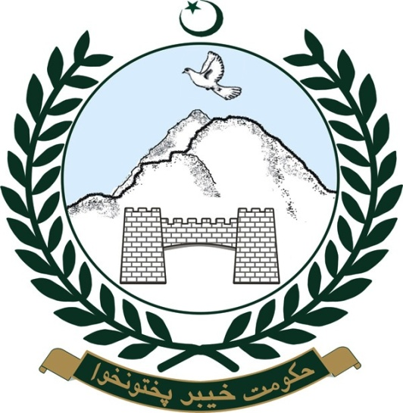

Khyber Pakhtunkhwa Department of Local Government, Elections and Rural Development

www.khyberpakhtunkhwa.gov.pk

# Organization

|  |  |
| --- | --- |
| **Contents** | |
| **Department** | Local Government, Elections and Rural Development |
| **Parent Department Name** |  |
| **Secretary** | Mr. Hifz ur Rehman |
| **Special Secretary** | Mr. Asghar Ali. |
| **List of Wings/Sub Units** | 1. Local Council Board, Peshawar. 2. Directorate General of LG&RD. 3. Peshawar Development Authority, Peshawar. 4. Galliyat Development Authority, Abbotabad. 5. Provincial Delimitation Authority. 6. Water And Sanitation & Hygiene (WASH) 7. Project, Clean Drinking Water for All, Peshawar. 8. Municipal Services Program. 9. All Development Authorities of 10. MDA, Mardan. 11. SDA, Swabi. 12. MDA, Mansehra. 13. ADA, Abbotabad. 14. KDA, Kohat. 15. KDA, Karak. 16. BDA, Bannu. 17. DDA, DI Khan. 18. SDA, Swat. |

# About US

|  |  |
| --- | --- |
| **Contents** | |
| **About us / Introduction** | * Up to 1959 the concept of Local Government was in vogue through District Boards, Municipal Committees and notified Area Committees * BD system was introduced in 1959. * In 1979 through an Ordinance the system was reinvigorated. * In 2001, The concept of Local government and devolution to lower level of management was re-organized and made more effective through Local Government Ordinance 2001. * The Khyber Pakhtunkhwa Local Government Act-2012 has been passed by Provincial Assembly, covering all aspects of Local Governments. * The new Local Government act is in the drafting stage with a vision of change and services at door steps. |
| **Organization Structure** | See attachment |
| **Functions** | 1. All matters connected with the Administration of the Khyber Pakhtunkhwa Local Government Act, 2012. 2. Child Marriage Restraint Act 1929. 3. Administrative controls of LLAs, GDA and PDA. 4. Provincial Delimitation Authority. 5. North West Frontier Province Public Property (Removal of Encroachment) Act, 1977. 6. Muslim Family Law Ordinance, 1962. 7. Hackney Carriage Act, 1879 and Stage Carriage Act, 1861. 8. Conciliation Court Ordinance, 1961. 9. Special Marriage Act, 1872. 10. Fire Brigade. 11. Census. 12. Burning and burial grounds and Muslim grave yards not taken over by the Auqaf Department. 13. Matter pertaining to the Election for the Provincial and National Assembly. 14. Provincial Election Authority and Provincial Election Tribunal concerning Local Councils. 15. Matters relating to Referendum on a national issue. 16. Village Police. 17. Rural Works Programme and Rural Uplift. 18. German Aid Financial Project (Pakistan Academy for Rural Development), and Budget and Accounts matter of Pakistan Academy for Rural Development (PARD) and Pakistan Provincial Services Academy (PPSA) development plans and development funds pertaining to Local Councils and Local Bodies. 19. Grant in Aid for Local Council. 20. Processing of ADP through District Coordination Committees. 21. Water Supply and Sewerage Schemes of Local Council. 22. U.S Aid Financial Project. 23. Asian Development Bank Assisted Projects (Farm to Market Roads through Local Councils). 24. World Food Programme. 25. UNICEF Programme. 26. Women Programme and Overseas Women Foundation. 27. Adult Education. 28. Village/Union Council Library Programme. 29. Local Council Reforms/Local Government Commission. 30. Matters relating to Kachi Abadi. 31. Village Electrification Programme. 32. Registration of Birth, Deaths and Marriage. 33. Slaughter houses under the Local Councils and Local Bodies (other than those in Cantonments). 34. Local Councils Services including Engineering and Health Services for Local Councils. 35. High / Low Selection Boards (LCS) and others matter relating to the Local Councils Services. 36. Service matters of the defunct Village Aid and B.D. Department. 37. Delegation of additional power to Local Councils. 38. Privileges and Protocol of Local Councilors. 39. Ponds and Prevention of cattle trespass. 40. Pre-Partition claims relating to Local Bodies. 41. Seminars, conventions and publications concerning Local Councils. 42. Local Councils contribution to Provincial Government. 43. Local Taxation and Local Rates. 44. Education Cess on Octroi. 45. Education Cess on Export Tax. 46. Urban Property Tax payable to Local Councils. 47. Aerial Spray Surcharges on Gur. 48. Local Government Pool Fund. 49. Local Government Research Statistics and Evalution. 50. Foreign delegations/training of Local Councilors. 51. Construction and minor repair of Basic Health Units and Primary Schools, Maktabs through Local Councils. 52. Arrangments of Horse and Cattle shows and fairs. 53. Jashan-i-Khyber Pakhtunkhwa. 54. Coordination of National Building Department through District Coordination Committees. 55. Management of Nazool Land. 56. Service matters except those entrusted to Establishment & Administration Department. |
| **Objectives** | * Empowerment of Local Governments (District, Tehsil, UC)   + Resource Distribution   + Policy Making   + Development Work * Good Governance   + Community Organizations / CCBs   + Grassroots Representation   + Parity between Rural & Urban areas * Delivery of Social Services   + Drinking Water Supply & Sanitation   + Health & Hygiene Promotion   + Education |
| **Vision / Future Plan** | * Realigning provincial policies and local government systems towards results. * Stimulating demand for and accountability in public services through CCBs, VDOs and other monitoring committees. * Improving the management of service delivery by local governments. * Confronting vested interests (giving voice to the people) * Develop linkages between Union Councils, MCs, District and Provincial through service structuring of secretaries of Union Council. |

# 1.3 Public Access to Government

*e.g. List of Phone No*

|  |  |
| --- | --- |
| **Official / Officers (Designation Only)** | **Address /Telephone No/Fax/Email** |
| **Secretary** | **0919210026 & 0919211450** |
| **Special Secretary** | **0919211726** |
| **Additional Secretary** | **0919210528** |
| **Deputy Secretary (Admin)** | **0919210523** |
| **Deputy Secretary (Development)** | **0919213327** |
| **Director General (D & M)** | **NIL** |
| **Deputy Director (D & M)** | **0919210596** |
| **Section Officer (General)** | **0919210059** |