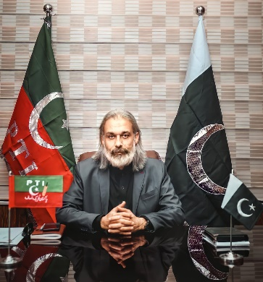
“We believe in creating development opportunities for the whole province so that everyone can benefit from our policies and projects”.

FAISAL AMIN KHAN
MINISTER FOR LOCAL GOVERNMENT,
ELECTIONS & RURAL DEVELOPMENT
GOVERNMENT OF KHYBER PAKHTUNKHWA

The policies of our results-led government reflect the development priorities and service delivery needs of the citizens in Khyber Pakhtunkhwa. In line with the Prime Minister’s vision and Chief Minister’s aspiration to improve the standards of local governance and municipal administration, it is my resolve to align our local government initiatives with the demands of citizens, as the key partners in collective progress.

We are working to transform the local governance landscape of Khyber Pakhtunkhwa through building the capacities of local governments to deliver, making substantial resources available for service delivery institutions, creating new infrastructure for urban development, and ensuring equal distribution of funds for rural investments. The extension of local government infrastructure and services to the Merged Areas is also one of our key local government priorities.

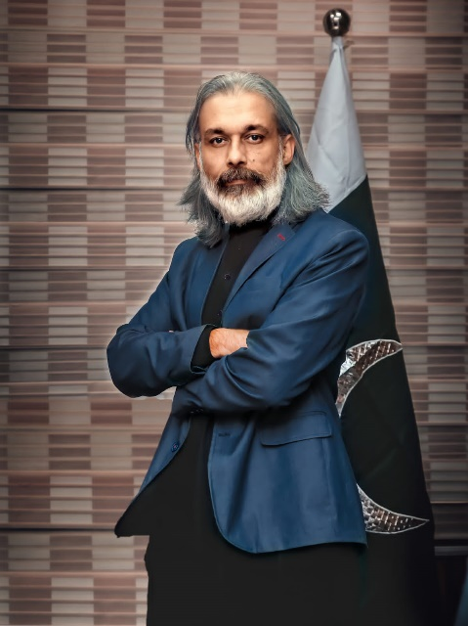
“Clean & Green” Khyber Pakhtunkhwa is very close my heart and we are already doing whatever it takes to achieve the Prime Minister’s vision. From scaling up sanitation facilities in major cities and proper disposal of solid waste to constructing environment-friendly infrastructure and providing green spaces for our citizens, we have put in place number of initiatives for conservation and safeguard of the environment.

Under the local government communication and outreach strategy, we are making use of different media platforms to reach out to our citizens and stakeholders. That is why we are capitalizing on digital media opportunities to further extend the reach of our digital media communications, including web-enabled platforms, to provide speedy and accessible information. Similarly, we want to provide avenues for open exchange of information to ensure transparency and openness in all our actions.

This website is one of these endeavors as a one-stop resource for sharing regular updates about our policies, plans and projects with you. Therefore, you are encouraged to browse through this website and benefit from the information made available through it. We are collectively learning and improving by working together. We also seek your constructive feedback on how we can reach out and serve you better.

